**GASTROSCOPY INSTRUCTION SHEET**

**Procedure Date___________** **Arrival Time at Hospital ________**

**Physician:**  **Dr. Saul Mandelbaum**

**3030 Lawrence Ave. E., Suite 209**

**Scarborough,  ON, M1P 2T7**

**416-431-1242   fax 416-431-0836**

**Location of procedure**

**(one of)**

|  |  |  |
| --- | --- | --- |
| **SCARBOROUGH HOSPITAL**    ***GENERAL CAMPUS***    **3050 Lawrence Avenue East**  **(at McCowan Road)**  **3rd Floor, East Wing**  **416-431-8200** | **Please check in at Patient registration on the ground floor first** |  |

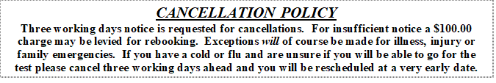

**Day Prior to Procedure:**

* Nothing to eat or drink from Midnight. If your gastroscopy is later the next

day, nothing to eat or drink 7 hours prior to exam.

**Day of the Procedure:**

* DO NOT EAT OR DRINK ANYTHING THAT DAY.
* If you take regular medication, you should have it the morning of the procedure

with a few sips of water.

* **You MAY NOT drive or take the bus the day of the**

**procedure.  Have someone drive you home. It cannot be an uber**

**or taxi unless someone you know is with you.**